Scenario 1 - Work Type: Credit Reporting
Query:
This account was discharged in bankruptcy.

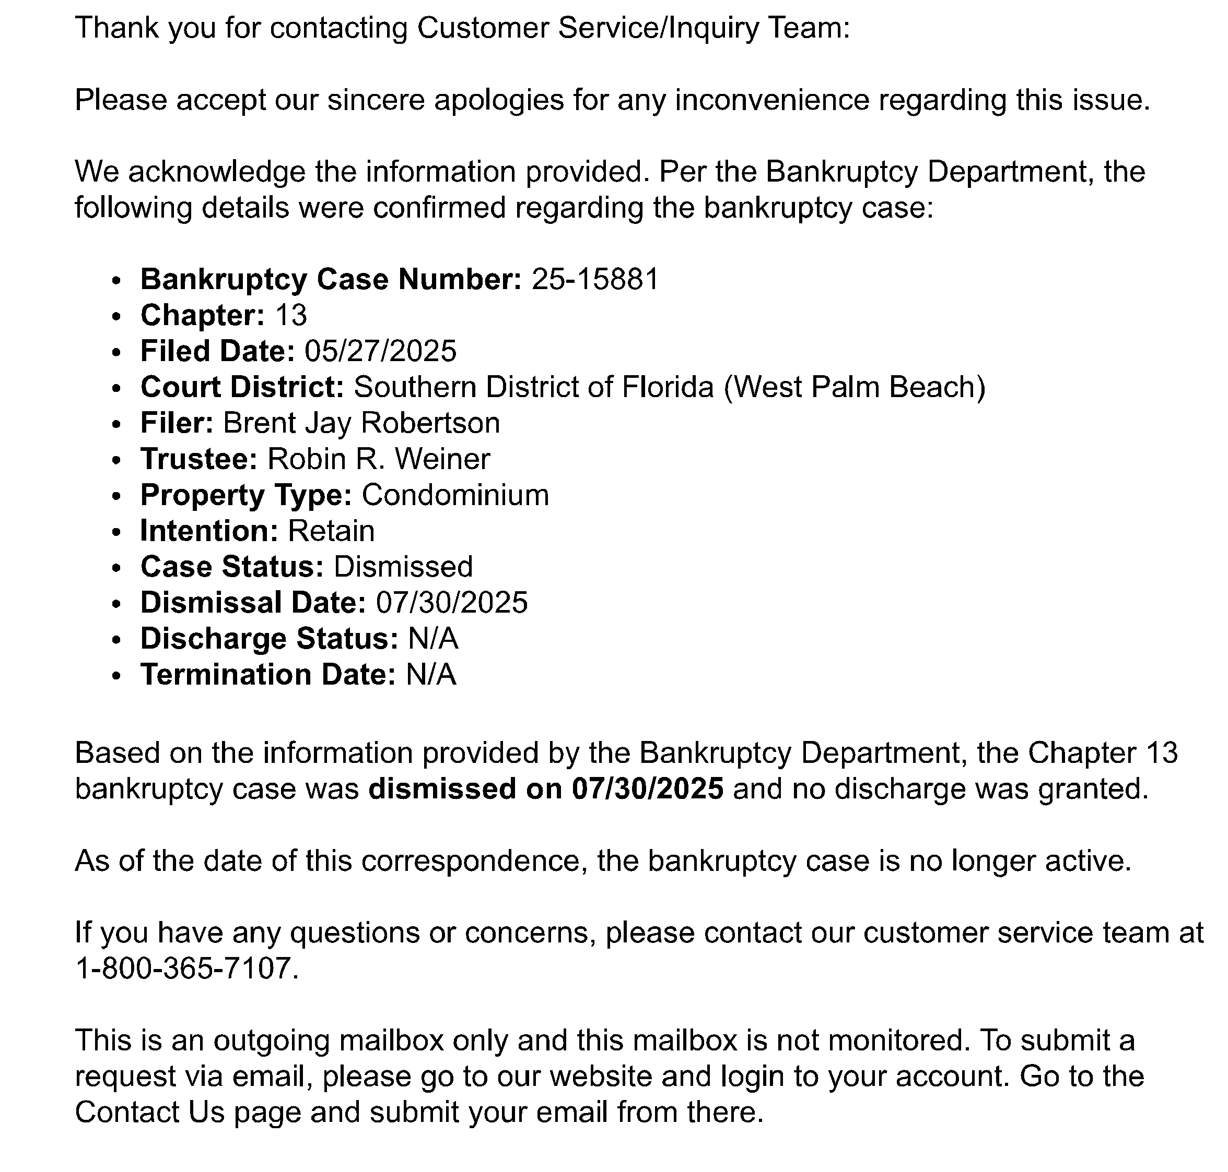
Respond send to the borrower:

